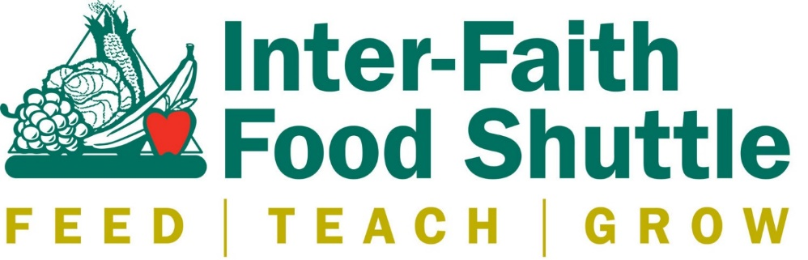

FOOD DRIVE REGISTRATION FORM
Date(s) of food drive: ________________________
Organization: _______________________________________________
Address: __________________________________________________________
__________________________________________________________
Contact Name: ______________________________
Phone Number: ________________________
E-mail Address: __________________________
Will you be using IFFS collection boxes? ________________
If so, contact Dre Richmond, fooddrives@foodshuttle.org, to schedule pickup.
When will you drop off donations at IFFS? __________ _ Raleigh location: 1001 Blair Dr. Raleigh, NC 27603. Durham location: 902 N. Mangum St. Durham, NC 27701.
For large food drive donations, we can pick-up the donations from your location.
- Large food drives are 1,000 pounds or more of food.
Date of Pick-up: _____________________
Preferred time of Pick up: ____________________
Pick-up Location (if different from address): ________________________________________
Will you need a donation receipt? Yes No
Will you be using any of the following media or social venues to promote the Food Drive?
______ Newspaper _______ Radio _______ Facebook _______ Twitter
Thank you so much for your time, dedication and commitment to holding a food drive to benefit Inter-Faith Food Shuttle. With your help, we can continue our fight against hunger in North Carolina. If you have any questions, please contact Dre Richmond at (919) 390-1957 or FoodDrives@foodshuttle.org.
SPECIAL NOTES: __________________________________________________________
Please submit this form to Dre Richmond at FoodDrives@foodshuttle.org.

